**10 Steps for Organizing Kitchen Cabinets**

One easy and satisfying place to start is kitchen cabinets.

1. Pretend it has a glass door on it and everyone is going to see what's inside from now on.

2. Take a look at the photos below for inspiration.

3. Remove EVERYTHING and scrub the shelves with some soapy water.

4. If your a contact-paper type of person, rip out the old and replace it with new. There are some really cute ones out there lately; I've seen them at Target (please share in the comments section if you have another good source).

5. Take anything you don't use anymore.

6. Think about what you reach for the most often and make sure it gets a position that's easy to reach.

7. Arrange everything in a composition that makes you happy. You're on your way.

8. Perhaps take a cabinet full of glasses and line them up by color. Make sure all of the fronts are facing out and straight, Jeff Lewis-style.

9. Take a step back after one shelf is done.

10. Make someone else come look at what you've done.

**Proper Storage of Cleaning Equipment**

**Storage of Washed Utensils**

1. They should be stored in a clean dry place adequately protected against vermin and other sources of contamination

2. Cups, bowls, and glasses shall be inverted for storage.

3. When not stored in closed cupboards or lockers, utensils and containers shall be covered or inverted whenever practicable. Utensils shall be stored on the bottom shelves of open cabinets below the working top level.

4. Racks, trays and shelves shall be made of materials that are imperious, corrosiveresistant, non-toxic, smooth, durable and resistant to chipping.

5. Drawers shall be made of the same materials and kept clean. Full-lined drawers are not acceptable, but the use of clean and removable towels for lining drawers is acceptable

Below are pictures showing proper storage and stacking of tools, utensils and equipments.

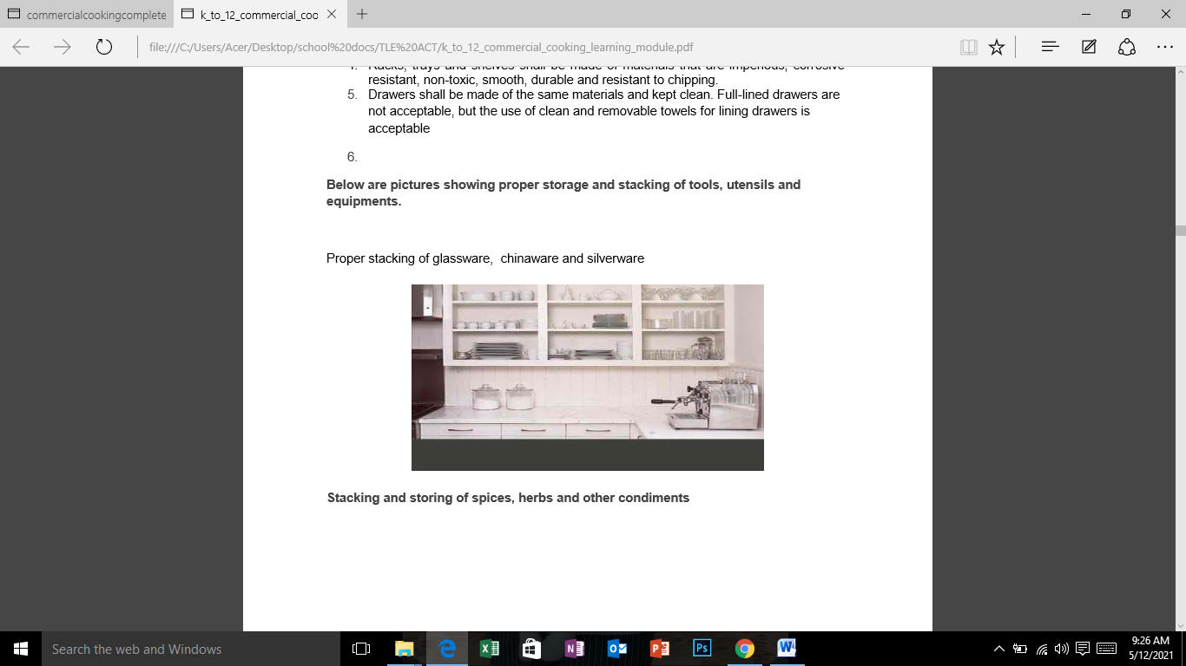

**Stacking and storing of spices, herbs and other condiments**

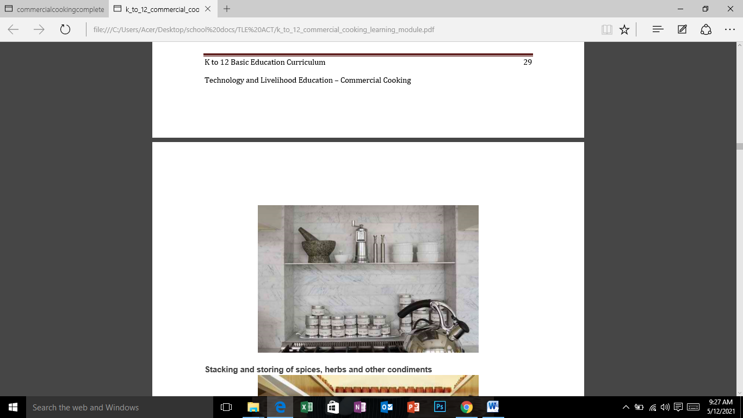

**Stacking and storing of spices, herbs and other condiments**

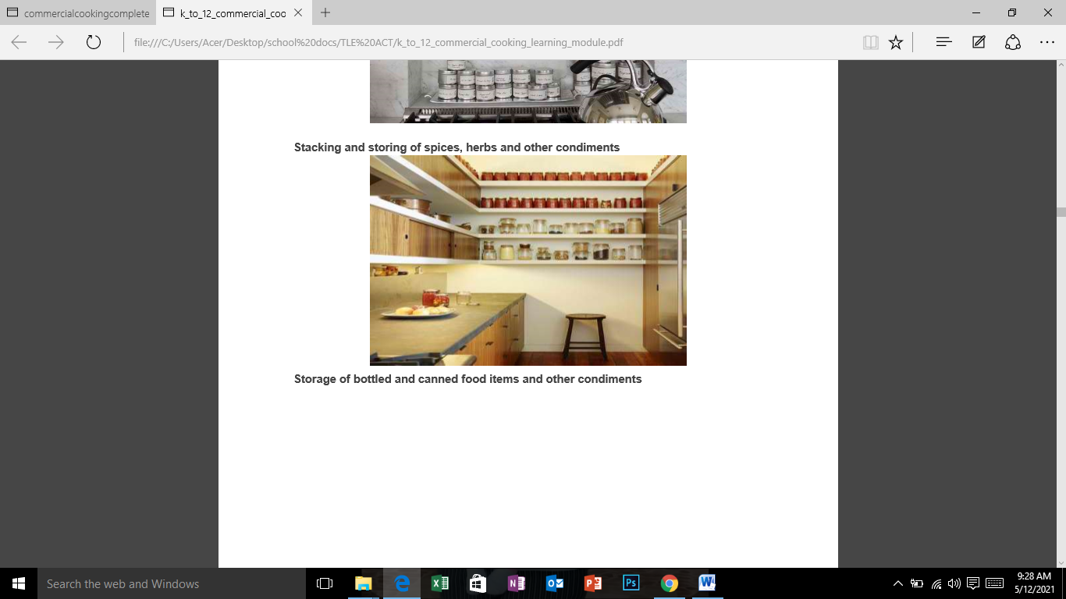

**Storage of bottled and canned food items and other condiments**

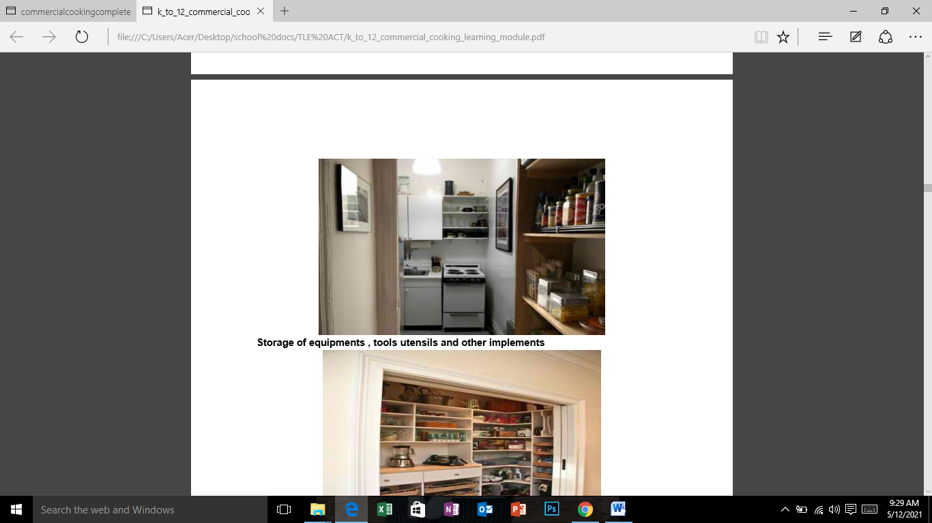

**Storage of equipments , tools utensils and other implements**

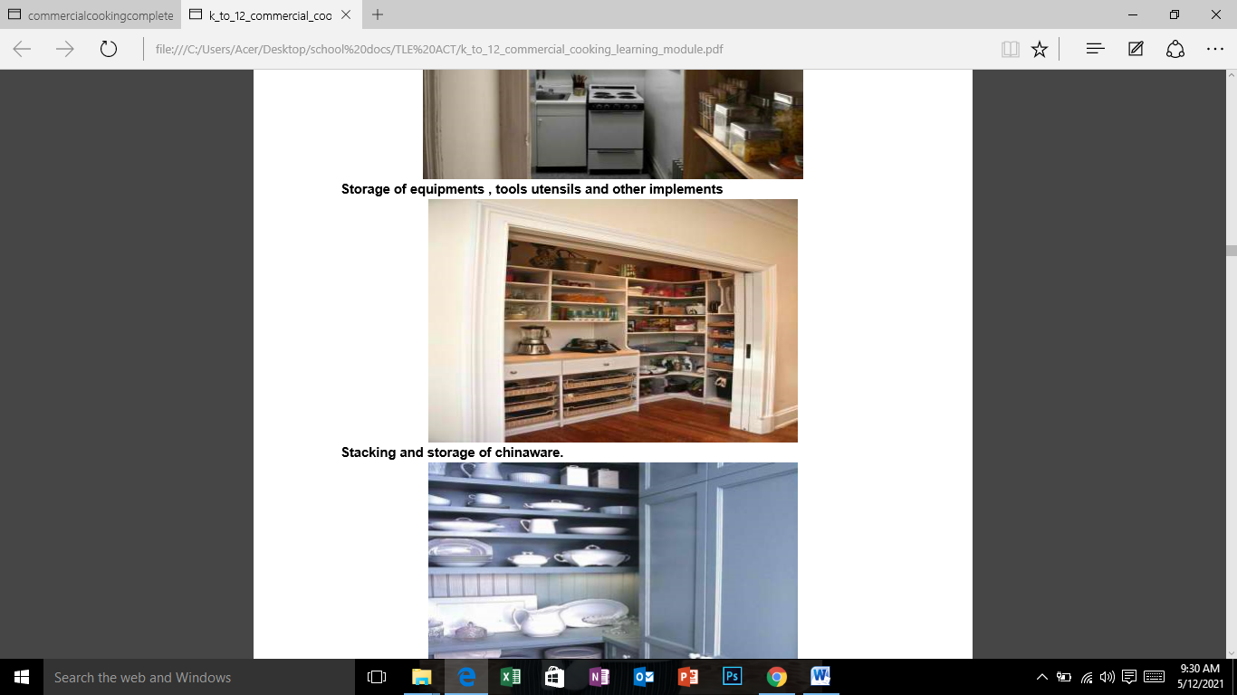

**Stacking and storage of chinaware.**

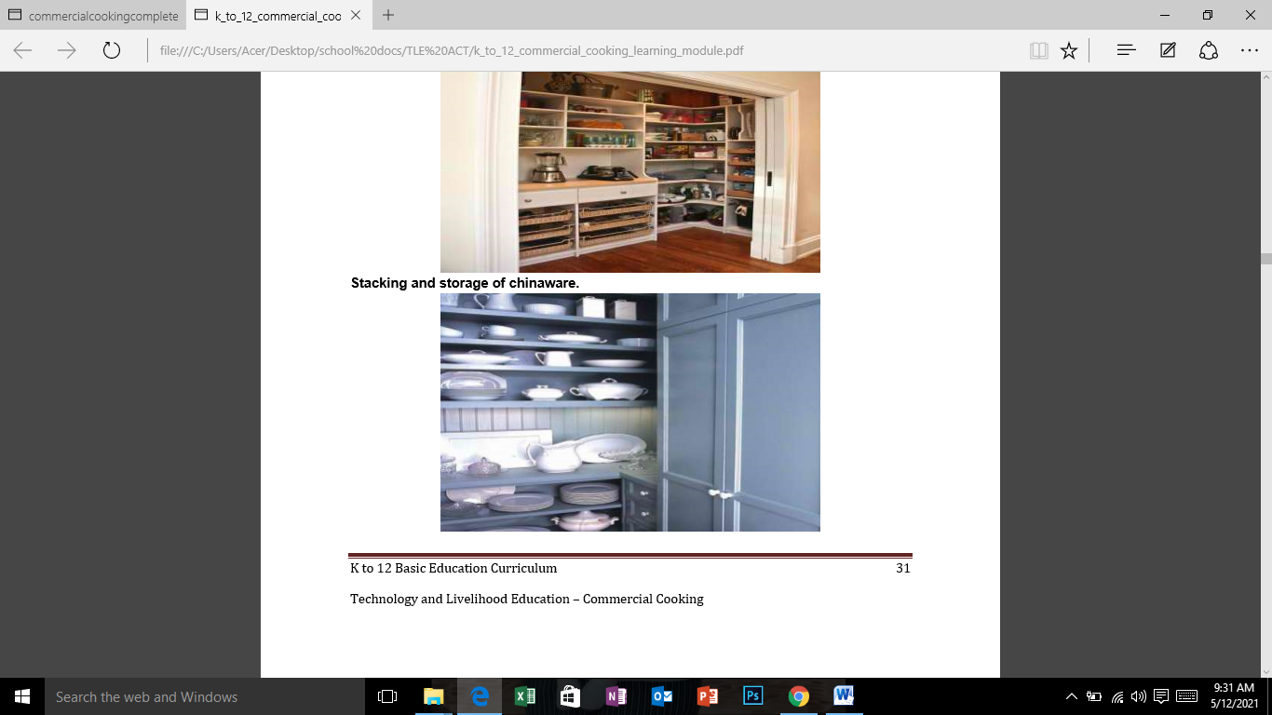

**Evaluation**

I. Answer the following questions:

1. Why it is important to clean, sanitize, and store equipment properly?

2. Enumerate ways on the proper storage of cleaning equipment.

II. Watch a video https://www.youtube.com/watch?v=69v6HiX9-FY

Observe how canteen staff store and stack kitchen tools and equipment. Take note of your observation and make comments/suggestion on how to improve their storing and stacking procedures.